Working With Combos
1. To activate the combos functionality, you need to have cuts defined.
2. Click on the combos Icon ( ) to launch the combos functionality. A combos window will appear that lists the available cuts that can be combined. Each available cut is numbered on the display and in the Define Groups box
3. Form a group by selecting cuts. To do this, you click on the box below ‘Group’ across from desired cut. The line turns blue to indicate that it has been selected.
4. If you want to allow the cut to be ‘flipped’ then hold the control key down and click on the box below ‘Flip’. An ‘X’ will appear in the box indicating that the cut can be flipped as a possible choice.
5. Items can be selected or deselected by clicking on them.
6. Once a set of cuts has been put together, clicking on ‘Combine’ forms a group, which will then appear in the ‘Process Groups’ box below.
7. In the Process Groups box you click on the button below ‘Show Options’ to display the available combinations.
8. Click on ‘Delete Group’ to delete the group.
9. To get rid of manual seam, alt-right-click over the manual seam.

Embedded Shortcuts
1. + sign does a complete-L with max area
2. – sign does a complete-L with min area

- Shift click on a selected line (purple line) in seam mode creates a manual seam.
- In seam mode, hitting the s key takes you to subdivide mode
- In seam mode, hitting the ‘a’ key takes you to area selection mode
- In seam mode, subdivide submode if you have created a subdivide line, hitting ‘enter’ completes the subdivision.
- Seam mode select manual seam by alt-key down and right key down.
- Alt-click on a manual seam deletes the manual seam.

Software Update Notes

1. Backout of complete L lines

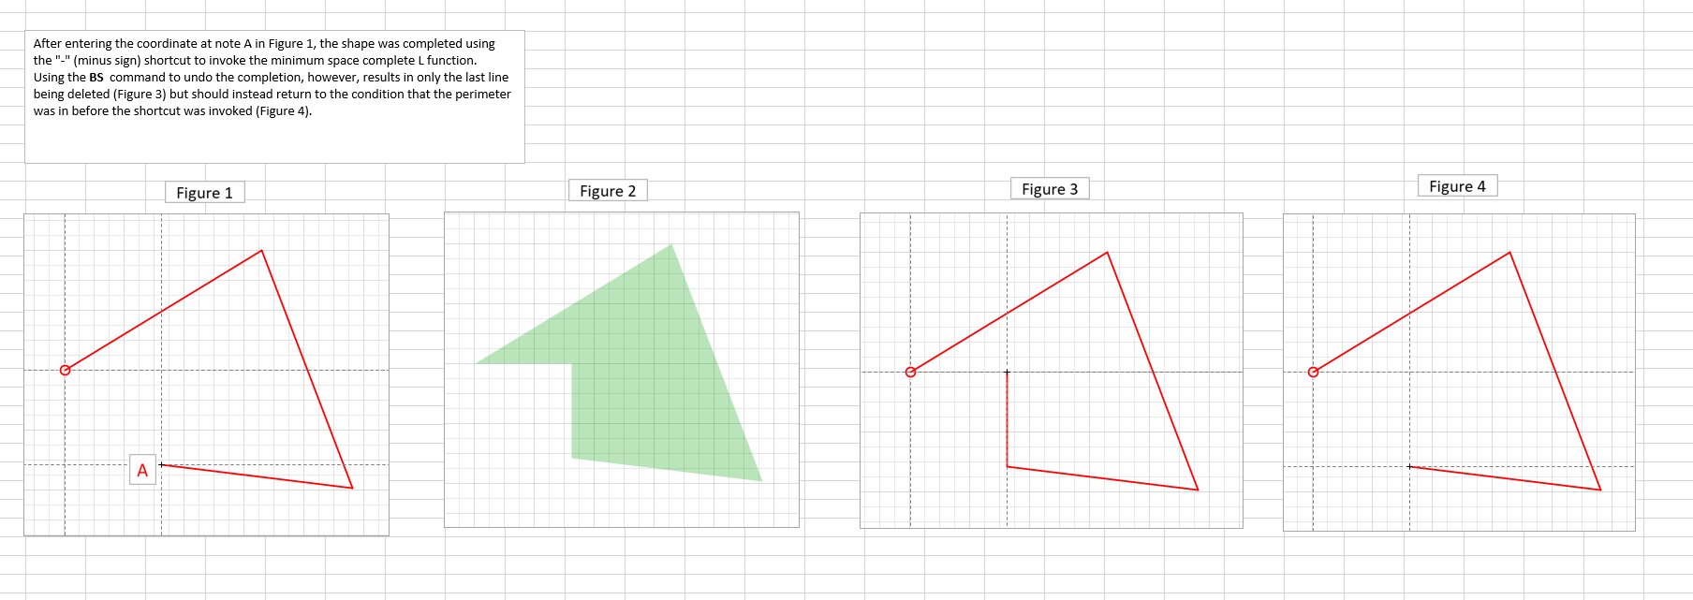

Back out from complete-L removes all (both) lines added in complete L. This is done in a kludgy way by adding an attribute ‘IsCompleteL’ to lines added. When the last line is backed out a check is made to see if the previous line is a complete L line is a complete L line. If this is the case then a recursive call is made to DeleteBuildingPolylineLastLine to remove this line also. A better solution would be to put markers on line points in Polyline line and back out until a marker is hit.

ToDo List:
1. Move seam layers back to the area finish level.

